

19 May, 2020

**Bug Report**

**Indbiz Project**

**Version 1.0**

|  |  |  |
| --- | --- | --- |
| This document outlines the general scope of your project based on our understanding of the requirements provided and discussions to date. |  |  |

**DISCLAIMER**

This document is submitted with the explicit understanding that the contents are confidential and would not be divulged to any third party without prior written consent from Dotsquares Ltd. Services are supplied according to our terms and conditions <http://www.dotsquares.com/terms>

# Revision History

|  |  |  |  |  |
| --- | --- | --- | --- | --- |
| **Version** | **Date** | **Description** | **Prepared by** | **Reviewed by** |
| 1.0 | May 19, 2020 | Bug report on admin | Meeta | Neeru |

# Admin Panel

1. Login >>Add wrong password>> no error message—it should show an error message with email id filled.
2. My profile section>> there is no way to edit the profile section.
3. My profile section>> change password>> name of page is wrong>>currently it is edit profile it should be change password.
4. Change password>> leave new password and confirm password blank>> click add button>> change password is getting update.
5. Change password>> Instead of add button >> it should be update button.
6. Change password >> fill new password and leave the confirm password>> click on add button>> change password is getting update.
7. Change password>>Fill new password and add wrong password in confirm password>> click on add button—change password is getting update.
8. There is no way to edit the profile picture, company picture and profile name.
9. Through contact section I am able to edit the profile
10. Contact section—text labels missing as on my profile section

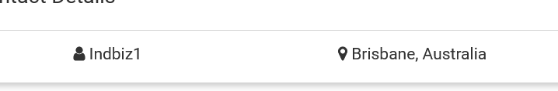

1. Edit contact>> phone number>> getting scroll which is not required
2. Edit contact>> phone number>> numeric validation missing
3. Edit contact>> able to edit email address which is wrong>> if it’s a requirement then a mail should be send and admin should logout.
4. Edit Contact>> leave username field blank>> no error message
5. More option >>left menu>> data protection>> not coming in same lines as other option’s

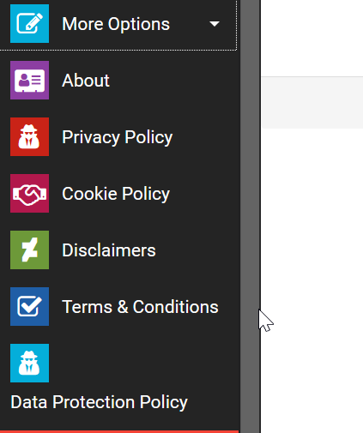

1. Listing>> export listing>>select car wash>>nothing is getting export.

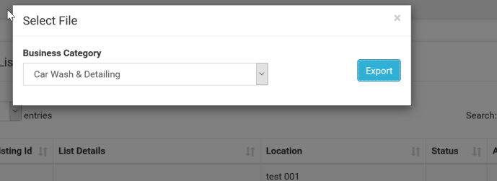

1. Listing>> copy listing >> spelling mistake of copy 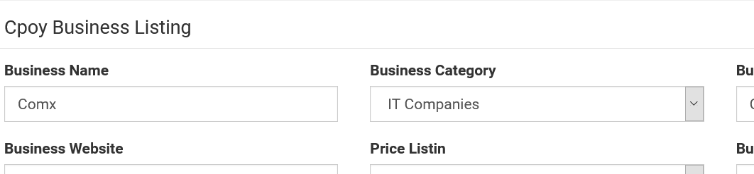
2. Edit Business listing>> spelling mistake of listing.

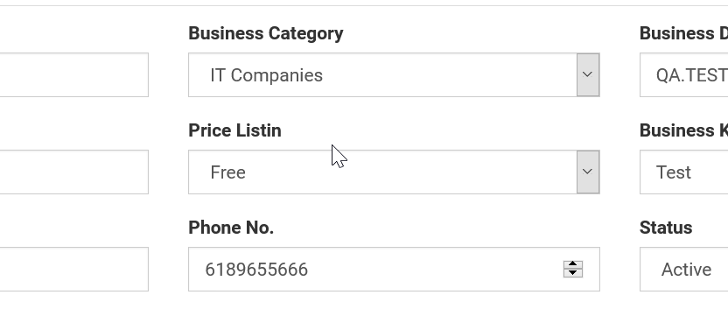

19. Edit business listing>> validation check missing from website url and phone number.

20. Edit Business listing>>able to enter start greater than end time.

21. Add Price/edit price>> Numeric /numeric length limit validation missing from price. 

22. Add Price>> leave any of the field blank and add price>> no error message

23. Add price>> No currency check is there when adding price.

24. Add state & city>>don’t fill any of the field and click on add >> no error message.

25. Add state & city>> I have marked “Queensland” as inactive but still getting when adding listing getting the Queensland as state

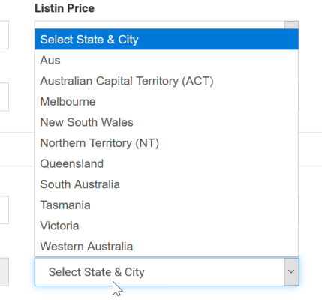

26. Category>> mark category as inactive but still getting when adding business listing and in website also.

27. category>> don’t fill any of the field and click on add >> no error message.

28. Category>> search any category>> filtered from text 27 distorted.

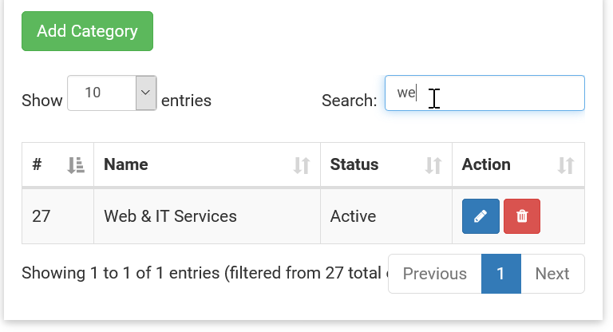

29. Category>>add sub category>> spelling mistake of category in” select category “ label

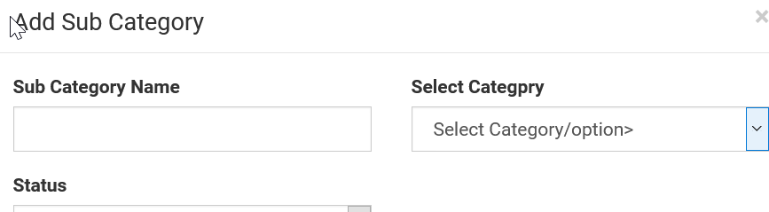

30. Category>>add sub category>>unwanted text under the select category

31. Category>> mark category as inactive but still getting when adding subcategory>> under select category drop down.